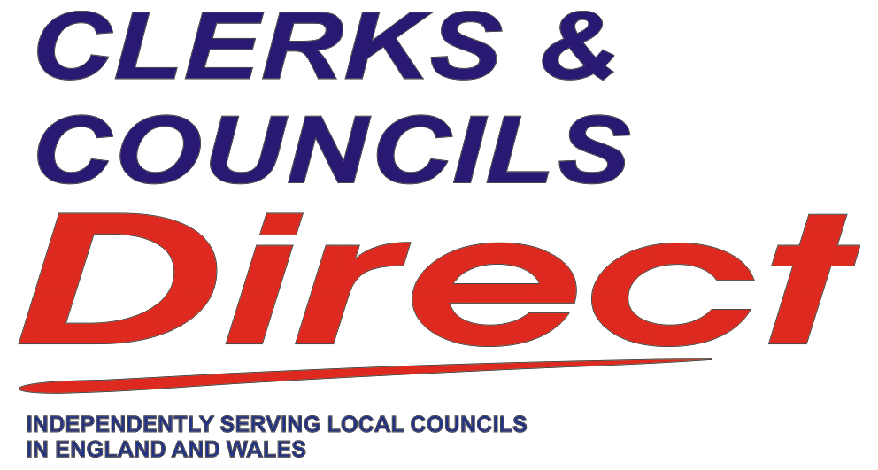 | Just £15.50 per year  for an independent view
COPIES FOR YOUR COUNCILLORS
SUBSCRIPTION ORDER FORM
Please mail DIRECT to the Councillors named below an individual copy of
Clerks & Councils Direct for 12 months at a rate of £15.50 per annum, per subscriber

Name………………………………………
Address…………………..……..………
………………………………....…..………
……………………………….….…..………
County……………………...….……….
Post Code……………….…..…………

Name………………………………………
Address…………………..……..………
………………………………....…..………
……………………………….….…..………
County……………………...….……….
Post Code……………….…..…………

Name………………………………………
Address…………………..……..………
………………………………....…..………
……………………………….….…..………
County……………………...….……….
Post Code……………….…..…………
Name………………………………………
Address…………………..……..………
………………………………....…..………
……………………………….….…..………
County……………………...….……….
Post Code……………….…..…………

Name………………………………………
Address…………………..……..………
………………………………....…..………
……………………………….….…..………
County……………………...….……….
Post Code……………….…..…………

Name………………………………………
Address…………………..……..………
………………………………....…..………
……………………………….….…..………
County……………………...….……….
Post Code……………….…..…………
Name………………………………………
Address…………………..……..………
………………………………....…..………
……………………………….….…..………
County……………………...….……….
Post Code……………….…..…………

Name………………………………………
Address…………………..……..………
………………………………....…..………
……………………………….….…..………
County……………………...….……….
Post Code……………….…..…………

Name………………………………………
Address…………………..……..………
………………………………....…..………
……………………………….….…..………
County……………………...….……….
Post Code……………….…..…………

Name of Council: ……………………………………………………………………………………………….………………………………………………
Clerk: ………………………………………….………………………………………………………………………………………………………..……………
Address: ……………………………………………………..……………………………….………………………………………………..………………...
………………………………………………………………………………………………….……………………………..……………………...................
County: …………………………………………………………………. Post Code: ……………………………………..…………………………
Tel: ..………………………………………………………..………………………………………………………….……………………………………………
Email ……………………………………………….……………………….………………..………………………………….……………..………………...
Total copies required @ £15.50/per subscriber/annum ……....
Amount due …………………………………….. You will be issued with a receipted invoice by email.
PAYMENT:
By cheque payable to CommuniCorp
By BACS to: Barclays Bank plc. Sort code: 20-31-52. Account: 30244996 CommuniCorp
Please post with cheque or remittance advice to: Subscription Department, CommuniCorp,
2 Micklefields, Stanton, Bury St Edmunds, Suffolk, IP31 2XF.
Tel: 01359 254149. Email: ClerksCouncils@btinternet.com

